**x**

**Window Film Care Instructions**

* **We hope you enjoy your newly installed 3M Window Film. The following are just a few details that are important for you to be aware of.**
* **Window film has a 30-day cure time during which you may see some visual changes in the material. It may appear cloudy, hazy, blotchy or distorted to some degree. This is the result of the moisture used during installation and is only temporary.**
* **You should leave all roll up windows in the up position for 4 days in the winter and 2 days in the summer for proper curing.**
* **You may clean the windows after 30 days with any non-abrasive glass cleaner (ammonia free). We recommend *Amsoil Glass Cleaner*.**
* **The material is scratch resistant however it is not scratch proof. Please use care when moving sharp or hard objects near the glass. Normal cleaning should not cause any damages.**
* **Your window film installation is an aftermarket process and is not done in an atmospherically controlled factory environment. As a result you may observe what appear to be small pinpoint specs or tiny bubbles in some areas upon close inspection. This is normal and is the result of tiny airborne particles or contaminants from the window frame and seals. We exercise great care to have the cleanest outcome possible however these things cannot be completely eliminated. WAO has a hassle-free customer satisfaction policy that assures all reasonable measures will be taken to meet customer’s satisfaction.**
* **We hope you enjoy your new film and with the proper care you can be assured of many years of satisfaction.**
* **All LEGAL window film jobs come with the 3M Limited Nationwide Lifetime warranty. The warranty covers film defects such as bubbling, cracking, delaminating and etc. It DOES NOT cover scratches.**
* **If you have any questions or concerns please contact us at (252) 435-6789**
* **Thank you again for your purchase.**

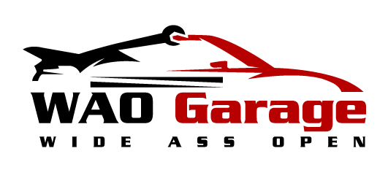

**Window Film Care Instructions**

* **We hope you enjoy your newly installed 3M Window Film. The following are just a few details that are important for you to be aware of.**
* **Window film has a 30 day cure time during which you may see some visual changes in the material. It may appear cloudy, hazy, blotchy or distorted to some degree. This is the result of the moisture used during installation and is only temporary.**
* **You should leave all roll up windows in the up position for 4 days in the winter and 2 days in the summer for proper curing.**
* **You may clean the windows after 30 days with any non-abrasive glass cleaner (ammonia free). We recommend *Amsoil Window Cleaner.***
* **The material is scratch resistant however it is not scratch proof. Please use care when moving sharp or hard objects near the glass. Normal cleaning should not cause any damages.**
* **You window film installation is an aftermarket process and is not done in an atmospherically controlled factory environment. As a result you may observe what appear to be small pinpoint specs or tiny bubbles in some area upon close inspection. This is normal and is the result of tiny airborne particles or contaminants from the window frame and seals. We exercise great care to have the cleanest outcome possible however these things cannot be completely eliminated. WAO has a hassle-free customer satisfaction policy that assures all reasonable measures will be taken to meet customer’s satisfaction.**
* **We hope you enjoy your new film and with the proper care you can be assured of many years of satisfaction.**
* **All LEGAL window film jobs come with the 3M Limited Lifetime warranty. The warranty covers film defects such as bubbling, cracking, delaminating and etc. It DOES NOT cover scratches.**
* **If you have any questions or concerns please contact us at (252) 435-6789**
* **Thank you again for your purchase.**